Name:
Professor:
Course:
Date:
Challenges Faced by Working Women in UAE

ABSTRACT
To understand the problems faced by working women in the UAE, which is a global challenge, it is necessary to discuss the problem from the perspective of developed economies. This paper examines the challenges faced by working women in the UAE, identifies the factors leading to the existence of these challenges, and provides strategies to address the issues. This research is supported by the survey conducted to ascertain the opinions of women working in the public, private, and civil sectors in the UAE. The findings of the survey show that women face numerous challenges, including a struggle with work-life balance, harassment at workplace, gender pay gap, managing between caring for their children, and accessing new career opportunities.
Based on the obtained results, certain indicators are vital, for example, equality, cohesion, provision of career opportunities, quality of life, and the ability to explore different opportunities. Identifying the correlation between the survey results and the future of working women in the UAE, it can be deduced that the present challenges can be addressed. By having a work-life balance, having equal pay as their male counterparts, being given career opportunities to advance themselves and being treated with respect at the workplace.
Keywords: Work-life balance, gender pay gap, hardships, women empowerment, social duties
Contents
ABSTRACT 1
INTRODUCTION 3
The scenario of Working Women 3
Research Questions 5
Aims and objectives 5
Objectives 5
LITERATURE REVIEW 5
Challenges Faced by Working Women in the Middle East 6
Challenges faced by women in the UAE 7
Factors Promoting Challenges Faced by Working Emirati Women 12
Approaches Used by Organizations to Address Challenges Faced by Working Emirati Women 13
HYPOTHESIS 14
METHODOLOGY 15
Research Design 15
Sample 16
Intervention practices 17
RESULTS 17
DATA ANALYSIS AND DISCUSSION 20
PLAN TO IMPLEMENT STRATEGIES DEVELOPED TO ADDRESS CHALLENGES FACED BY WORKING EMIRATI WOMEN 29
LIMITATIONS OF RESEARCH 30
CONCLUSION AND RECOMMENDATIONS 31
Discussion 31
Works Cited 33
APPENDIX A 36
APPENDIX B 46

INTRODUCTION
This paper aims to conduct a comprehensive research about the challenges, which working women in the United Arab Emirates (UAE) face. These problems are historical and continue to affect women's ability to perform optimally in their careers. The report will have two literature reviews on the challenges faced by women in the working class. These reviews will be followed analysis of literature. The next section will be the methodology, which will cover choosing participants, sampling, and data collection. A results section and data analysis will be included. There will be the development of a strategic plan to address the problem and a plan to implement the agenda in public discourse. A plan to evaluate the effectiveness of the created procedure will be developed. Limitations of the study will be discussed and a conclusions section provided.

The scenario of Working Women
Over the last ten years, different studies have been conducted to determine the various challenges working women in developed economies face. Statistical information tracking working women globally indicate that majority of them struggle with work-life balance, harassment at the workplace, gender pay gap, managing between caring for their children, and accessing new career opportunities (The Atlantic). In developed economies, women play an important role in social, economic, political, and cultural development. However, their ability to perform optimally in these roles is inhibited by the existing economic policies, which eventually lead to the problem of occupational segregation.
The UAE is one of the most economically developed regions in the world. Despite the observed economic development, the percentage of women in the labor force is very small. This small percentage can be linked to the existing social perceptions and policies that inhibit the participation of women in the labour force. According to a report by Muhtaseb that was published in the Arabian Business, UAE has a vast female talent pool that can be harnessed to work in complex and competitive workplaces. However, due to policies, cultural traditions, and the position of the woman in society, working women continue to face pressure, affecting their motivation, performance, and productivity.
Traditionally, women have played a key role in keeping the Islamic religion in the region intact. Women have also been perceived as housewives, with their main role to nurture children and take care of children. Implementation of policies that support the inclusion of women in the labour force and changing perceptions about women has led to an increase in the number of women in the workforce. Data collected by the World Bank shows an increasing trend in the number of Emirati women in the labour force in the last ten years. In 2020, there were 17.71% Emirati women in the labour force, compared to 11.14% in 2010 as shown in figure 1 below (Trading Economics).
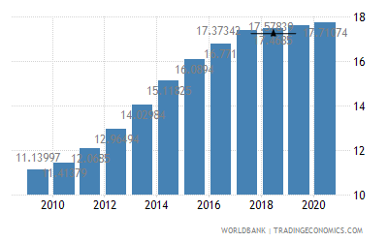
Fig 1: Percentage of the female labour force in the UAE from 2010 to 2020. (Source: The World Bank).
An increase in the percentage of women in the labor force can be linked to the increasing number of women enrolling in schools. Promoting education among women and women empowerment programs have enabled women to advance themselves, personally and professionally. Educating women has also improved their literacy levels, allowing them to work in political and economic scenes. Despite that the position of women has been elevated in the community, they still face numerous challenges. Thus, it is necessary to develop strategies that can minimize the severity of the problems which women face in the workplace.

Research Questions
- How women maintain a balance between their personal and professional lives?'
- How their families and the relationships between husbands and children are affected?'

Aims and objectives
This report aims to discuss the challenges that women in the labour force in the UAE face. Also, the report will offer strategies that can be used to alleviate the severity of these challenges.

Objectives
- Examine challenges faced by working women in the Middle East
- Examine the challenge faced by working women in the UAE
- Explore factors promoting identified challenges
- Implement solutions to the identified issues

LITERATURE REVIEW
This chapter will include two literature reviews. The first literature review will address challenges faced by working women in the Middle East, UAE, and the factors which promote the problems. The second literature review will discuss how different institutions have helped to address the challenges. Also, the chapter will discuss approaches that can be used to implement and sustain change in the region's labour force.

Challenges Faced by Working Women in the Middle East
Women working in the Middle East today experience a broad range of challenges, both at the workplace and family. Challenges faced at the workplace include unequal pay, lack of leadership opportunities, gender bias, harassment, and insufficient maternity leave. Working women at the family face challenges like time balance, responsibilities of a mother, social duties, and limited time with the family because of business trips and meetings. These two categories of challenges are consistent with the roles which women play in the social and economic levels of a family. Women get an education and enter into the labour market to advance their families' economic status, personal advancement, and achieve higher social status. The ability of women to achieve a higher financial status in the family gives them economic freedom. However, the achievement of economic independence comes with a couple of challenges. To begin with, the Arab society is structured under masculine structures (Sanhouri). In this context, women in the Middle East are feminized. Women are seen as fragile. Their fragility is associated with the issue of insecurity. Different researches over the years in this region show an increase in the rate of the abduction of female (Wanninayake). As a result, different policies have been implemented to limit their movement. Limiting women’s movement directly affects their ability to optimally engage in the labour force. These policies have negative implications on women because work demand at least eight working hours.
Another challenge is the high poverty rate among women compared to men. The 2018 World Inequality report shows that Arab societies have developed discriminatory practices over the years. These practices are believed to begin at birth; for instance, women are discriminated against from birth, allowing men to advance themselves further. The gap that exists between men and women from birth inhibits their abilities to succeed in academics and life in general. Women are denied the ability to access the necessary resources for their advancement in education and the labour market. Lack of skills in life, which is linked to the gender gap, exposes women to poverty. Also, women who get an education are exposed to the challenges of getting employed. Due to feminization, women are perceived as weak and unable to reach employers’ expectations. Majority of employers in the Middle East prefer to employ men, limiting women from potential employment opportunities.

Challenges faced by women in the UAE
Women in the UAE are among the most respected people in the world because of the advocacy of social justice in its constitution. Since the start of the 21st century, women have played a critical role in social, economic, cultural, and political development in the region. In the UAE, women have been allowed to advance themselves in the labour market. Women are allowed to advance themselves alongside men, helping them to gain economic independence.
Although social perceptions about women have rapidly changed in the last two decades, women working in the Middle East continue to face social pressures and overwhelming barriers to advance themselves. According to Verma and Mulani, working women face a challenge when it comes to the acquisition of leadership positions in workplaces. Limited leadership opportunities are associated with the fact that most leadership positions in the UAE are held by men (Muhtaseb). With leadership positions being dominated by men, women are left with limited opportunities to be included. Male dominance in leadership positions is associated with the problem of gender biases. As previously stated, Emirati women begin to face biases in the early stages of life, which makes it a challenge for society to accept women working in the same spaces as men. In almost all major commercial sectors, male dominance in leadership and other positions is visible. As a result, the community develops with an unequal distribution of resources between men and women.
Another challenge faced by working Emirati women is work-life balance. Work-life balance is one of the major challenges affecting employees across the world. It is a challenge associated with the inability to coordinate between work roles and family life. Organizations that do not support their employees' work-life balance can incur direct and indirect costs due to reduced employee productivity, increased employee turnover, high-stress levels, and long overtime hours (Jabeen et al). Emirati women can now advance themselves because of the new policies implemented to give women equal rights and opportunities as their male counterparts. Today, Emirati women account for 45% of the active employees in the UAE. More than 40,700 Emirati women are currently in the labour force, which is a significant increase in the last two decades. The quality, proportionality, and components of the work environment in the UAE have promotes the position of women. The public sector accounts for 40% of the total female workers with only 5% working in the private sector (MENA-FN). The higher number of female employees in the public sector is associated with higher benefits, job security, and promotion of employee work-life balance. Although the public sector plays a critical role in the promotion of women's economic independence, the sector has been experiencing higher turnover in recent generations (Jabeen et al). In a 2015 UAE Federal Government report, it was identified that women accounted for the highest employee turnover, at 64% (Federal Authority for Government Human Resources).
The achievement of work-life balance for women working in the UAE is critical because it is a determining factor of the region’s continued progress in economic and social aspects of life. Despite the role of organizations in public and private sectors to promote work-life balance, Emirati women still face challenges at work because of inconsistency between their interests and organizational demands. As a result, women tend to quickly change jobs in search of satisfaction. High employee turnover among women can be associated with a lack of job satisfaction, misalignment between work roles and personal life, and distressing operations at the workplace. Work-life balance among Emirati women is a major challenge because career and professional life for women is perceived as a secondary role, after taking care of the family’s needs. In the process of trying to balance between work and personal life, women can often get stressed, which in turn, affects their ability to work optimally and even fulfill family expectations.
Emirati women in the labour force also face the challenge of mental and physical harassment at the workplace and even in their homes.
Despite the significant changes, which have taken place in the UAE in terms of improving women's lives, health, and promote economic independence, they are still perceived and "second hand" citizens. In this context, women are controlled by men because they lack an opportunity to engage in making decisions that affect their lives and family. Because of the dominance of male leadership at the workplaces and at home, female employees are left vulnerable to harassment and discrimination. Begum states that women are required to respect the decisions of their husband's and their male counterparts, contrary to which they are considered to have broken the law. The inclusion of discriminatory laws in the constitution limits the ability to work women to make independent decisions. Gender-based violence in the UAE is also associated with the fact their laws do not address violence against women, or rather provide guidelines to the courts and the entire justice system. The law fails to outlines the roles and responsibilities of government agencies, the police, courts, and non-profit agencies in the protection of women's rights. Therefore, instances of harassment at workplaces and in their homes can be taken for granted, leaving the women vulnerable and unable to perform optimally. Women are also excluded from labour law protections, which exposes them to higher probabilities of abuse, harassment, and exploitation (Begum). Reports by the Human Rights Watch have shown that some local and migrant women working in the UAE can work for up to twenty-one hours in a day. Also, instances of sexual and physical abuse have been reported. However, reporting these cases has not changed the situation, considering there are no provisions in the constitution on how the justice system can address the issues.
The codes which have been developed over the years in the Islamic culture require women to seek their husbands' permission before they engage in any decision or duty. Working Emirati women have to get permission from their husbands in order to get employment or even take part in work meetings. Women working in leadership positions are under high pressure, particularly when it comes to attending work meetings and training programs. They have to seek their husbands' consent, otherwise, it is considered a violation of Islamic law. Before engaging in these meetings and training programs, they also have to ensure that their children are well taken care of throughout the time. Also, they have to ensure that everyone in the family is on board with the plan. Subjecting women to these tough working conditions and balancing them with family expectations exposes them to high probabilities of developing stress and other mental health issues.
Because of the problem of insecurity and vulnerability of women in the UAE, many families do not support women engaging in the labour market. Cultural traditions are framed in such a way that women's primary role is to take care of domestic chores while men go to work and promote their families' financial status. Failing to support working women and limiting their work time significantly affects their performances in their work, prompting them to miss out on important organizational promotions (Al jenaibi).
In terms of payment, women are paid lower wages compared to their male counterparts. Although women have shown their increased competence and performance compared to men, they are still paid at lower rates, which affects their motivation to work and perform better. In a 2020 report by the World Economic Forum (WEF), it was identified that the Middle Eastern region was in the lower 25th percentile in terms of gender gap pay (Ryan). The UAE was ranked 120th out of 153 countries in the Global Gender Gap Index. These statistics show that there is a major gap between men and women in terms of wages. In the same report, it was estimated if the same policies implemented to address the gender gap will be used, it could take more than a century and a half to address the gap. Thus, studies portray that despite policies addressing women's position in the labour market, much needs to be done to achieve equality.
Another challenge that working Emirati women face is the inability to address the needs of their children and husbands. Working women spend most of their time in their work, attending meetings, and other training programs. These work activities prompt them to miss out on important activities through their children's development and learning process. Children who grow without the influence of their mothers in their education, health, and physical development can lack important skills like how to socialize, how to multitask, and how to solve real-life problems. Mothers also play a critical role in the creation of social bonds between their children, husbands, and the entire community. These ties are vital for the future success of the children. However, due to work roles, women poorly perform their social duties, which can affect the wellbeing of the family.

Factors Promoting Challenges Faced by Working Emirati Women
Numerous challenges have been associated with the increased severity of challenges facing working Emirati women. One of the factors is the existing cultural and social restrictions that the constitution has among women. These restrictions increase the severity of the discussed challenges because they are denied an opportunity to get an education and the necessary tools to help them succeed in the highly competitive and dynamic labour market. The second factor is the established masculine culture, which inhibits women’s movement and the achievement of economic independence. Arabic traditions, which are the basis of the country’s constitution restrict the ability of women to engage in different activities. Besides, families, which are led by men restrict women from seeking employment. These restrictions are linked to the assumption that women’s primary role is to be a housewife. The third factor is the failure of the constitution to have provisions addressing women's security and equality in the family setting. In this context, men are the key decisionmakers, with women required to follow the decisions of the man. Also, in the case of violation of a husband’s rules, she can be punished according to the law. The constitution has provisions allowing men to punish their wives as long as there are no visible bruises. Violence against women decreases their ability to enter or succeed in the labour market. Although the access and use of technology among Emirati women has increased significantly, there is still a huge gap compared to the percentage of men accessing technology. These differences hinder the ability of women to contribute to the business world. Figure 2 below shows the number of women engaging in business operations using ICT. Lack of business training and mentoring is also linked with the increased severity of challenges facing working women in the Emirates. Women are hardly allowed to showcase their talents and capabilities. Employers seek to employ male employees. Whom they perceive to be better performers. Failure to give women an opportunity and train them puts them at a disadvantage compared to their male counterparts (International Finance Corporation (IFC) and Center for Arab Women for Training and Research (CAWTAR)). Besides, the fact that most of the leadership positions in the public and private sector are dominated by men, it becomes a challenge for qualified or rather competent women to get trained and mentored for different roles. Due to lack of training and mentoring, thousands of qualified and talented women end up wasting their skills and giving up on employment.
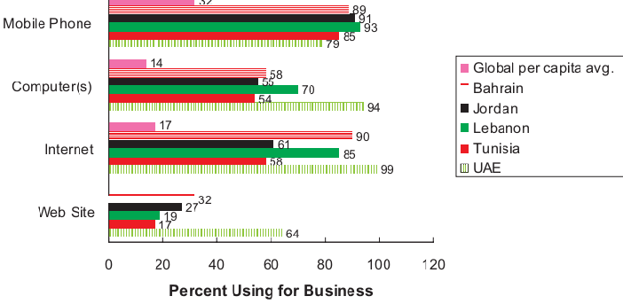
Fig 2: Percentage of women engaging in business through ICT (Source: MENA, 2010).

Approaches Used by Organizations to Address Challenges Faced by Working Emirati Women
Today, public, private, and non-profit organizations play a key role in the process of empowering women to become a staple of corporate activity in the country. These organizations have played an important role because women are considered an underutilized resource in the labour market. In a report by Wesely and Dublon. Due to the fact women have contributed towards the growth of UAE’s GDP by approximately 12%, different organizations have taken an interest to empower this population and tap the underutilized talents. An organization like the Center of Arab Women for Training and Research (CAWTAR) plays a critical role in the promotion of Arab women's role in the labour market. This organization has five programs, which are designed to promote the position of women. CAWTAR researches the development of Arab women and publishes them to create awareness on how these developments have gradually evolved. The organization empowers women to be part of the country's labour force by developing training programs, which are consistent with their interests and academic attainments. Another approach used by organizations in the UAE to alleviate the challenges faced by working women is establishing networks and partnerships between educated women and potential employers and amongst themselves. These partnerships are essential and can be used to reach talented and educated women in marginalized areas and who are underprivileged. Organizations have also maximized the use of technologies to promote communication, integration, and learning processes. The presence of several social media platforms enables women to showcase their capabilities to potential employers. Through these platforms, they can access more employment opportunities and obtain relevant information in real-time. The introduction of digital technologies in business is vital because it helps women engage in online businesses.

HYPOTHESIS
This study seeks to test the following hypothesis.
H1: There are various challenges while working women maintain the balance between their professional and personal lives.
The variables of the study are outlined below.
Independent variable – Working women
Dependent variable – husband and children

METHODOLOGY

Research Design
The inclusion of a methodology in research is necessary because it offers insights into how data was gathered and the analysis processes involved. According to Oh, there are different research methods, including experiments, interviews, questionnaires, case studies, surveys, and observational trials among others. The most commonly used methods are qualitative and quantitative research methods. Qualitative research focuses on gaining an understanding of the reasons, perspectives, and motivations towards a certain activity. This method of research helps researchers develop hypotheses for research. Additionally, is it used to determine trends in processes that are essential for gaining a deeper understanding of a research problem? Qualitative research methods include observational studies, interviews, and group discussions (Oh). On the other hand, quantitative research methods focus on quantifying a problem by providing quantified data that can be translated into meaningful statistics. Quantitative research methods on the other hand are structured. They can include surveys, systematic observations, interviews, online polls, and questionnaires (Oh). Therefore, in the process of conducting research, it is essential to understand the appropriate research method that can answer the research question. According to Oh, understanding a research method is essential for researchers because it helps determine the results and conclusions. Also, they can be used to help in the process of developing research recommendations.
Conducting this study is important because it will improve on the existing knowledge about challenges facing working Emirati women. Also, the research will help in the development of strategies that can be used to alleviate the severity of these challenges among women. For this study, the most appropriate research method is a quantitative method. A survey will be conducted to gather the findings of the research. Different factors will be put into consideration during the study.
The first consideration to make is to consider the rights of the participants. The research will put into consideration five ethical principles to protect the wellbeing of participants. The first principle is to ensure that participants are not exposed to any harm, to obtain informed consent, protect the participants' privacy, avoid immoral practices, and provide the participants with the right to withdraw from research.
Another thing that will be considered in the research is the collection of data. Different variables of data will be collected and used to compare the existing knowledge and that from the findings to determine the best approaches to address challenges faced by working women. A survey will be conducted using questionnaires. Participants will be required to answer 30 questions. These questionnaires will be sent by mail to all participants. Participants will be given one week to address the questions and send the answered sheet via mail. This process will ensure that data is not tampered with and that the information provided by the participants is correctly used. Different techniques will be used to analyze the data to determine its meaning. The analysis of the results using SPSS software will also be used to help the researcher to draw informed conclusions.

Sample
The population used in the research will be carefully selected to ensure that the objectives of the research are met. A randomized sampling technique will be employed to ensure that the research has an equal representation of the study population. Additionally, a random sampling technique will ensure that all study groups are included, thus promoting the achievement of reliable results. An adequate sample size (two-hundred working Emirati men and women) will be used in the research to ensure that the results obtained are conclusive. The sample will include eighty men and 120 women. Besides, an adequate number of participants is important because it will ensure that the results are generalized.

Intervention practices
Intervention practices will also be put in place to ensure that any unexpected changes during the research are addressed. Intervention practices are also important because they ensure that the research does not deviate from the expected outcomes with a big margin. The procedure of data collection will also be closely monitored to ensure that there is no bias. Biasness will also be avoided by having expert opinions from other experienced clinicians. Firsthand information from the participants will be obtained by the use of questions asked by email.

RESULTS
The results of the survey are presented in the tables and charts below.
Table 1: Showing the age of participants, gender, and the number of working women.
Age (years) | No. of participants | Gender |  | Employment status of the Females
 |  | Male | Female
0 – 15 | 2 |  | 2 | 0
16 – 30 | 87 | 27 | 60 | 56
31 – 45 | 89 | 48 | 41 | 42
46+ | 22 | 5 | 7 | 9

Table 2: Education attainment of the participants
Level of education | No. of participants
High school | 46
Bachelor’s degree | 146
Master’s degree | 7
Ph. D. | 1

Chart 1: Level of education
Table 3: Level of household income
Household income | No. of participants
Less than $25000 | 48
$25000 - $50000 | 100
$50000 - $100000 | 30
$100000 - $200000 | 20
Above $200000 | 2

Chart 2: Level of household income
Table 4: Likert scale
Likert question | Strongly disagree | disagree | neither agree nor disagree | agree | strongly agree |  | Mean | SD
I | 2 | 10 | 20 | 56 | 112 |  | 4.33 | 0.919
II | 0 | 0 | 5 | 65 | 130 |  | 4.63 | 0.535
III | 20 | 14 | 28 | 31 | 107 |  | 3.96 | 1.365
IV | 5 | 33 | 11 | 57 | 94 |  | 4.01 | 1.190
V | 78 | 69 | 12 | 19 | 22 |  | 2.19 | 1.339
VI | 67 | 70 | 19 | 31 | 13 |  | 2.27 | 1.254
VII | 13 | 23 | 60 | 55 | 49 |  | 3.52 | 1.169
VIII | 4 | 10 | 11 | 44 | 131 |  | 4.44 | 0.949
IX | 2 | 17 | 8 | 71 | 102 |  | 4.27 | 0.955
X | 45 | 50 | 23 | 63 | 19 |  | 2.81 | 1.348
XI | 19 | 41 | 20 | 54 | 66 |  | 3.54 | 1.378
XII | 8 | 12 | 12 | 76 | 92 |  | 4.16 | 1.049
XIII | 104 | 56 | 13 | 17 | 10 |  | 1.87 | 1.168
XIV | 99 | 67 | 4 | 21 | 9 |  | 1.87 | 1.153
XV | 4 | 2 | 20 | 78 | 96 |  | 4.30 | 0.845

DATA ANALYSIS AND DISCUSSION
The results in Table 1 shows the number of women of different ages who are in the labour force. From the obtained responses, 107 respondents were found to be working. Fifty-six workers, were between ages 15 – 30 years. 42 of the employees were between ages 30 and 45. Nine workers were identified to be over forty-five years of age. Some of the responses provided in table 1 were provided by male participants, who responded to their wives' employment status.
Findings in this table indicate that the number of female workers in the UAE has increased over the years. Young female employees between ages 15 – 30 represented the majority of the employees, accounting for 52.33% of the employed population. Women between ages 30 – 45 accounted for 39.2% of the employed participants and those aged above 45 years accounted for 8.4%. These findings indicate that more young female recruits are being included in the labour force.
Results in Table 2 indicate the level of educational attainment for the participants. The level of education with the largest population was a Bachelor’s degree, with 146 respondents, followed by high school with 46 respondents, Master’s degree with 7 respondents and Ph. D. with 1 respondent. This table shows a significant increase in educational attainment among women. Increased education attainment can be linked to the increased number of employed Emirati women, as identified in table 1. The results of table 2 are also represented in chart 1 as shown.
Table 3 provides findings on annual income in $. Majority of the females (50%) were paid between $25000 - $50000 per year. 24% of the participants responded that they earned less than $25000 per year. 15% of the women earned between $50000 - $100000 per year, 10% of the women earned between $100000 - $200000, and 1% earned above $200000 per year as shown in chart 2. These findings indicate that there is still a wide gender wage gap between working men and women in the UAE. The most paying careers most preferably were designated for men, cramming women in the lower-paying jobs. Despite that approximately 40% of Emirati women work in the public sector, which offers better job security, they are still paid less for the same job done by men. 1% of females earning above $200000 per year indicates that very few women are in executive and leadership positions.
The findings in table 4 represent responses of participants regarding different challenges facing working women in the UAE. In the question of the role of cultural values on women’s professional development, 122 respondents strongly agreed that cultural values hindered women from developing professionally. 56 participants agreed that cultural values contributed to decreased professional development among Emirati women. 20 of the participants were neutral regarding the question, 10 disagreed and 2 strongly disagreed. In this context, cultural values were identified to be a major challenge affecting working women in the country.
In the second question regarding work-life balance, 130 of the respondents strongly agreed that work-life balance was a problem facing female workers. 65 participants agreed while five were neutral. None of the participants disagreed or strongly disagreed with this challenge. In this context, work-life balance can be identified as a major problem because there were no responses to disagree.
Responses on the question about work hours showed that 107 participants agreed that women work for longer hours compared to their male counterparts. 31 of the participants agreed that women spent more time than men working. 28 participants were neutral regarding this question. 14 responses disagreed that women worked for a long hour and 20 participants strongly disagreed. Despite that some participants believed that men worked for longer hours than women, majority of the respondents agreed that women spend most of their time at work.
Question four focused on gathering information on whether husbands helped their women attend to their family roles. This question was based on the fact that UAE is perceived to be a masculine society, where women’s primary role is taking care of the family. 94 of the participants strongly agreed that their husbands did not help them in household roles. 57 agreed that they did not get help from their husbands. 11 of the participants neither agreed nor disagreed with the question. 33 participants agreed that their husbands helped them attend to household roles. 5 of the participants strongly agreed that their husbands helped them attend to their household challenges. These findings indicate that most women worked double time, i.e., at workplaces and in their families. These roles re-linked to inhibiting their performance at work and productivity. Findings in question four are substantiated by those in question 5. Question 5 focused on finding the role of husbands in helping lower their wives’ stress levels. 78 participants strongly disagreed that their husbands helped lower their stress levels. 69 disagreed that their husbands helped lower their stress levels. 12 respondents neither agreed nor disagreed with the question. 19 agreed that their husbands played a role in the alleviation of their stress levels. 22 strongly agreed to be assisted by their husbands lower their stress levels.
Responses to question 6 show that majority of men believed that women should not be allowed to achieve economic independence. 67 participants strongly disagreed that men supported women being in the labour market. 70 participants agreed that most men did not support the fact that women were in the labour market. 19 were neutral, 31 agreed that men proposed that women should be in the labour market and 13 strongly agreed that men support women in the labour market. These findings show that majority of men still oppose the involvement of women in employment.
Participants responded to a question on the perceptions and appreciation of the roles played by women at work and in their families. 49 participants strongly agreed that their children appreciated the roles they played at work and in the family. 55 participants agreed that the roles they played were appreciated. 60 were neutral regarding this question. 23 disagreed that their roles were appreciated and 12 strongly disagreed to the same. These findings show that the roles women play at work and in the family are appreciated. However, there is a large percentage of women, whose roles are not appreciated. Lack of appreciation lowers their morale, performance levels, and productivity.
Question 8 was designed to address the effectiveness of policies implemented to address challenges facing women in the labour market. 131 participants strongly agreed that the implemented policies to address challenges facing working women were ineffective. 44 agreed that these policies fail to address challenges facing women. 11 participants neither agreed nor disagreed with the question. 10 disagreed with the incompetence of the policies and 4 strongly disagreed that the policies address challenges faced by working Emirati women. These results show that existing policies affect the ability of women to enter or succeed in the work environment.
Majority of the participants agreed that the percentage of women in the labour force has increased significantly in the 21st century. 102 participants in the study agreed that the percentage of women who have been employed increased in the 21st century. 71 agreed to the increased number of women in the workforce. 8 neither agreed nor disagreed with an increase in the percentage of working women. 17 disagreed that the 21st century was characterized by an increase in the number of female employees. 2 of the participants in the study strongly disagreed with an increase in the number of employed females. These responses show that the country has changed its social perceptions and policies to promote equality between men and women. An increase in the number of employed women is associated with increased educational attainment.
The other question that was addressed was whether women are better performers compared to men. 19 participants in this study strongly agreed that women are better performers than men. 63 agreed that women were better performers than men. 23 were neutral regarding the performance between men and women. 50 disagreed that women were better performers compared to men. 45 strongly disagreed that women performed better than men. These results show that majority of the participants believed that men were better performers than women.
Another challenge that was addressed in the questions was the gender wage gap. 66 participants strongly agreed that the gender wage gap has remained the same over the years. 54 participants agreed that there has been a change in the gender wage gap. 20 responses were neutral regarding this question. 41 disagreed that there has not been a change in wages paid to men and women. 19 responders strongly disagreed with the claim that there has not been a change in the gender wage gap over the years. These findings show that women face the challenge of lower pay for the same job done by men. Getting lower pay for the same job is a challenge because they are not motivated and have to work twice as hard as men for similar benefits.
The lack of suitable nurseries for children is another challenge faced by working Emirati women. 92 participants strongly agreed that there were limited suitable nurseries for their children. 76 agreed that there was a lack of suitable nurseries. 12 neither agreed nor disagreed with this claim. 12 participants disagreed that there were limited suitable nurseries. 8 strongly disagreed that there was a challenge in finding suitable nurseries. Results show that this was a challenge facing women because lack if suitable nurseries imply that they have to take care of their children, and thus miss out on work.

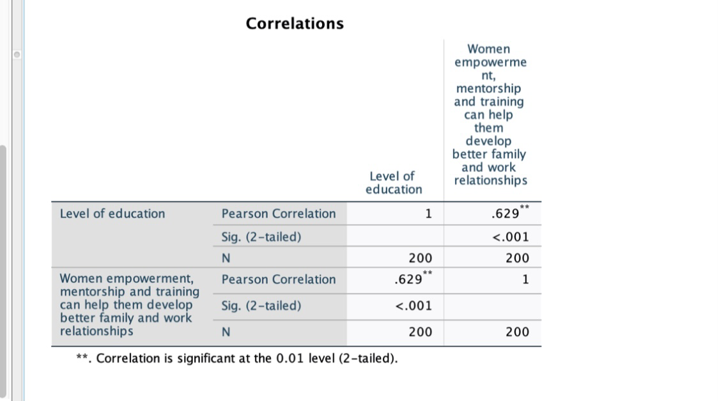
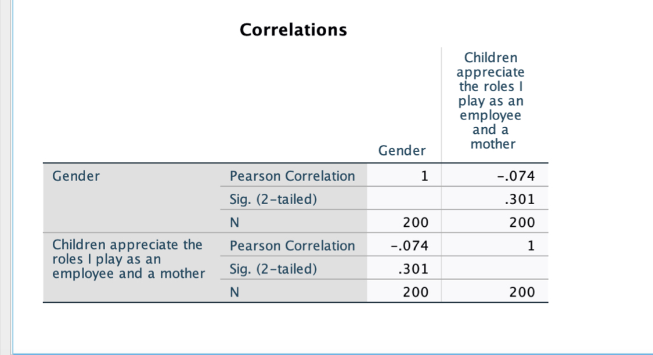

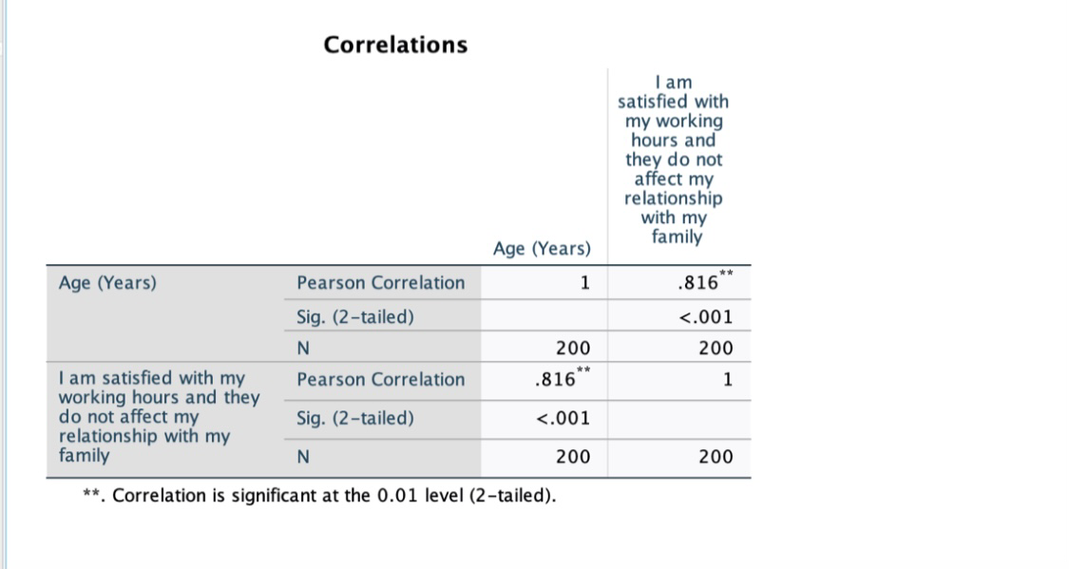
The analysis came to the conclusion that women are appreciated in the family. They are committed to both motherhood and work responsibilities. This means that women working in the UAE are dynamic and can handle their responsibilities efficiently. However, they must get training which will empower them in performing their duties.
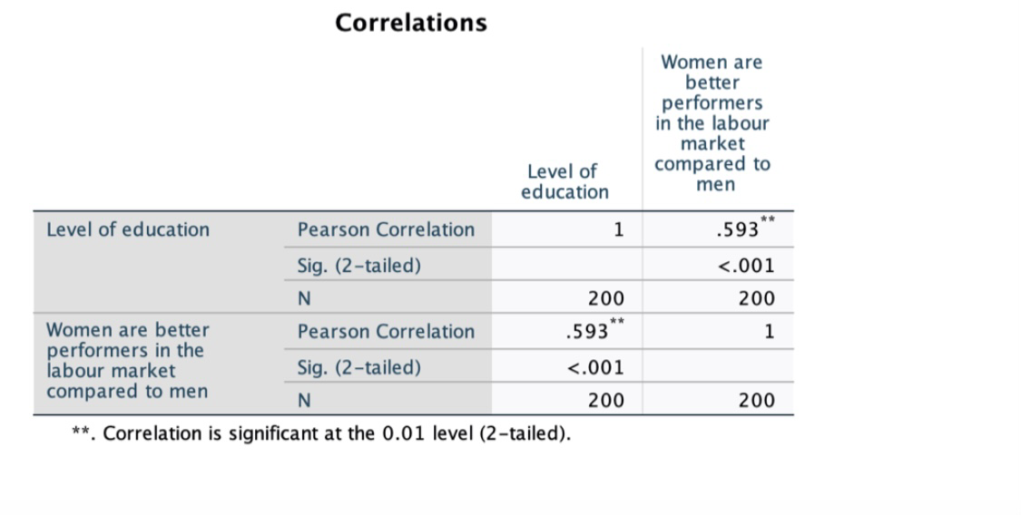
According to the analysis, more than three-quarters of the women interviewed, stated that relationships affect their working hours. On the other hand, women perform better in the labour market compared to their male counterparts.
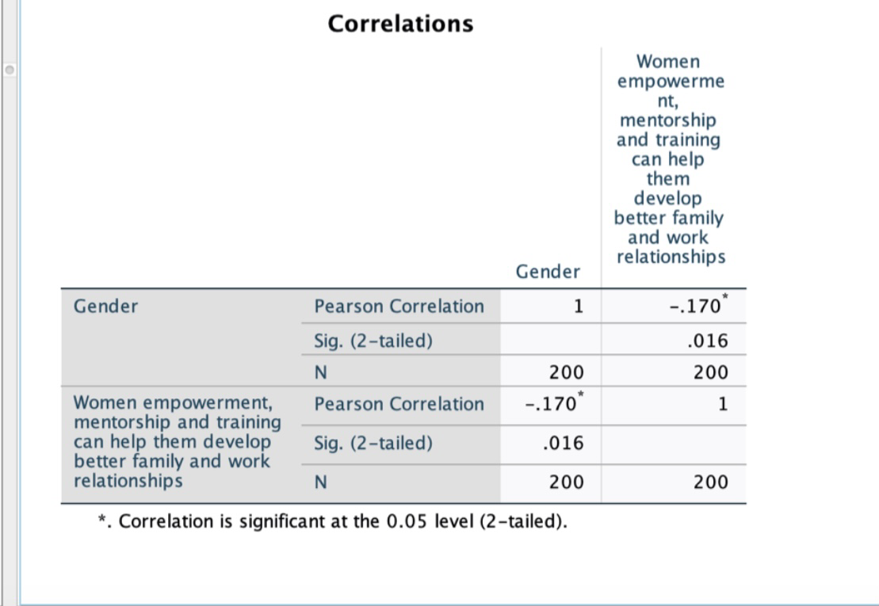

Discussion and testing hypothesis
According to the study, the hypotheses are true and the literature review is clear in handling of the study. For example, Hypotheses of H1: there is relationship between challenges and women working in the UAE. From the questionnaires, there is direct relationship with women and the challenges faced in their work areas across UAE. This was clear when the participants whom were administered the questionnaires stated that women face multiple challenges while working in the UAE. Most of the women who filled in the questionnaire stated that they have a major problem trying to switch from family responsibilities to job responsibilities.
The second hypothesis H2: more challenges means more discrimination against the women who need support. The change in the manner women are viewed in the society is essential. Women play an important role in the society and they should be assisted in their areas of need. Women need policies which protect them in their work places since they play an important role in the UAE.
Effects of working hours on the relationship with the family were addressed in question 13. 104 women strongly disagreed that they were satisfied with the hours they spend at work. 56 disagreed that they were satisfied with their work hours. 13 neither agreed nor disagreed with this claim. 17 agreed that they were satisfied with the hours they spend at work and did not affect their relationships with family. 10 strongly agreed that they were satisfied with the hours they spend working and had no negative effects on their relationships with their family. Findings gathered from these responses show that majority of working women had problems managing between work and family. Spending more time at work affected their relationships with their families.
Another challenge faced by working women is the lack of opportunities. This challenge was addressed in question 14. 99 participants strongly disagreed that there were adequate employment opportunities for women. 67 disagreed with this claim while 4 participants remained neutral. 21 participants agreed that women had adequate job opportunities. 9 responders strongly agreed that women have many employment opportunities. These responses show that women have limited opportunities to get employment compared with men.
The last question in the survey addressed the role of women empowerment, training, and mentorship. 96 participants strongly agreed that women empowerment, training, and mentorship can help women develop better work and family relationships. 78 agreed that empowerment, training, and mentorship were necessary for women’s success. 20 neither agreed nor disagreed with the claim. 2 participants disagreed that empowerment, training, and mentorship could improve work and family relationships for working women. 4 participants strongly disagreed with this claim. Findings in these responses indicate that empowerment, training, and mentorship play a critical role in the success of working Emirati women.

PLAN TO IMPLEMENT STRATEGIES DEVELOPED TO ADDRESS CHALLENGES FACED BY WORKING EMIRATI WOMEN
The plan will focus on achieving a work-life balance, reducing the gender wage gap, empowering, mentoring, and training women, and enhancing the implementation of effective and inclusive labour market policies. The strategic plan presented in the literature review analysis will be implemented using the following approach. The first step will be the communication of objectives. Executive leaders in the community will communicate goals that are consistent with the community's vision and values. By sharing these objectives with the affected population, they will be better positioned to align them with the concept. Weekly meetings will be necessary to communicate goals and review performances.
The second thing that needs to be done is driving accountability. Executives in organizations will need to lead by example, working towards the achievement of an equal work environment. All stakeholders will be held responsible for their tasks. Proper allocation of duties will establish competitiveness among employees and promote productivity. This step will require leaders to use the transformational leadership approach. Transformational leadership is an effective form of leadership that focuses on enhancing employee awareness of roles, understanding organizational and personal goals, and addressing employee needs (Bilgic et al). Transformational leaders inspire and motivate employees, which, in turn, builds their confidence, trust, and self-esteem. Female workers can borrow positive attributes from these leaders and applying them in the workplace. Transformational leaders are considered role models and mentors. Further, these leaders can transfer relevant knowledge and skills to employees, consistent with the organizational goals and values (Wong et al). Being a role model is essential because it fosters innovativeness and creativity among women. When people interact with others who are more knowledgeable, the probability of developing competitive skills increases. When leaders pass positive behaviours to employees, they support the team's innovativeness, which, in turn, promotes progress and organizational success.
All stakeholders need to be action-oriented. This approach focuses on taking the appropriate actions to achieve goals. Female employees will optimally achieve their objectives depending on the ability of managers to train and motivate them. Integrating rigorous training programs will increase women’s understanding of what is expected of them. Also, training programs increase competence and the ability to achieve organizational and personal goals.

LIMITATIONS OF RESEARCH
Limitations to this research include vulnerability to loss of information, biasness, and narrowing the study to selected sectors. These limitations affected the authenticity of the results.

CONCLUSION AND RECOMMENDATIONS

Discussion
Since women in the UAE are facing a lot of challenges, it is important to empower them. They are not supposed to suffer or side-lined based on religion, or just because of their gender. Women have proved to be resourceful once their energy is capitalized in the UAE. A good example is a country like the USA which has the first vice president-elect being a woman. Funny enough, she has blood from the Asian community. In UAE, women need improvement of their skills or literacy levels and empowerment from the family unit up to the national level. We need to have organizations realizing the need to empower women in the UAE. For example, the UAE government can set aside a kitty or funding program for women to benefit from. For example, the kitty can promote women to open their businesses. Once the women are empowered, they are less likely to be taken for granted in the community. Women should not be viewed as sex objects. It is, therefore, the responsibility of the government and the legal framework to set up policies that protect and support women's rights in UAE
In conclusion, the results of the research show that working Emirati women faced numerous challenges. These challenges affected their abilities to balance between personal and professional lives and sustain healthy relationships with their children and husbands. Challenges affecting working women in the UAE can include a struggle with work-life balance, harassment at the workplace, managing between caring for their children, and accessing new career opportunities. Approaches that can be used to address these challenges can be maintaining a balance between knowledge, skills, and behavior, implementing inclusive labour market policies, supporting women empowerment, mentorship, and training, educating more women, creating job opportunities for women, motivating female employees, and introducing more women to use technologies in businesses.
UAE has been in the frontline in support of women in their job place. Though women face a lot of challenges such as being a mother and a workers at the same time, the government has provided measures which ensure women rights are protected in the UAE. The government has come up with policies which are intended to close the gap between men and women in the working place. These policies ensure that women are not discriminated and that they are given equal chances just like their male counterparts. When women are discriminated against only to allow the men to thrive in the community, it becomes an unfair society and on the other hand, a violation of human rights. Women should not be set up barriers that hinder them from becoming what they want in their workplaces or families. They have the potential to flourish if allowed to study, showcase their talent, or put their knowledge learned in school in place. It is therefore our duty, in general, to empower the girl child to pursue their dreams in UAE.

Works Cited
Al jenaibi, Badreya. The Needs and Priorities of Women in UAE: Identifying Struggles and Enhancing Satisfaction of Employment, Education, Healthcare, and Rights. Contemporary Review of the Middle East. (2015), 2. 10.1177/2347798915601590.
Begum, Rothna. "Time to Take Action for Women in the United Arab Emirates."(2015). Available at https://www.hrw.org/news/2015/03/08/time-take-action-women-united-arab-emirates
Bilgic, R., Bulazer, M. B., Burumlu, E., Ozturk, I., & Tasciogiu, C. The effect of leadership on safety outcomes: The mediating roles of trust and safety climate. International Journal of Occupational Safety and Health, (2016), 6.1, 8-17.
Federal Authority for Government Human Resources. “Overview and analysis of employee turnover in the UAE federal entities (subject of HR law) 2014”. (2015). Available at https://www.fahr.gov.ae/Portal/Userfiles/Assets/Documents/42f53175.pdf
IFC and CAWTAR. Women Entrepreneurs in the Middle East and North Africa: Characteristics, Contributions and Challenges. (2007).
Jabeen, Fauzia, Friesen Heather. L., and Ghoudi Kilani. Quality of work life of Emirati women and its influence on job satisfaction and turnover intention. Journal of Organizational Change Management. 31.2: 2018, 352-370.
MENA-FN. Over 40,000 Emirati women employed in Abu Dhabi’s public and private sectors. (2020). Available at https://menafn.com/1100705788/Over-40000-Emirati-women-employed-in-Abu-Dhabis-public-and-private-sectors
Muhtaseb, Yasmeen. Challenges facing women in the Middle East workforce. Available at https://www.arabianbusiness.com/content/376292-challenges-facing-women-in-the-middle-east-workforce
Ryan, Patrick. "Global Women's Forum Dubai: gender pay equality in Middle East still 150 years away." (2020). https://www.thenationalnews.com/uae/government/global-women-s-forum-dubai-gender-pay-equality-in-middle-east-still-150-years-away-1.980495
Salam, Abdul. Challenges Faced by Working Women in Al Ain City. International Journal of Humanities and Social Science. 2. 189-197. 10.20469/ijhss.2.20005-5
Sanhouri, M. Family and obstacles hindering Emirati women from engaging work. (2014). Available at https://goo.gl/z3NEmF
The Atlantic. The Top Five Issues for Working Women Around the World. (2019). Available at https://www.theatlantic.com/sponsored/thomson-reuters-davos/the-top-five-issues-for-working-women-around-the-world/762/
Verma, Aarti and Mulaniu Mahesh. Challenges and Issues of Working Women in the 21st Century. International Journal of Research in all Subjects in Multi Languages. 6.3: 2018, 2321-2853
Wesely, Marissa, and Dublon Dina. Empowering Women at the Grassroots. Stanford Social Innovation Review. Spring 2015. Available at https://ssir.org/articles/entryempowering-women-at-the=grassroot#
Wong, J. H., Kelloway, E. K., and Makhan, W. Safety leadership. The Wiley Blackwell Handbook of the Psychology of Occupational Safety and Workplace Health, (2015), 83-110.
World Inequality Report 2018.

APPENDIX A
Survey Questions
To test the hypothesis and answer the research questions, thirty survey questions were formulated, fifteen based on demographics and fifteen based on the identified variables.
Demographic questions
- What is your gender?
- Male
- Female
- Prefer not to answer
- What is your age?
- 0 – 15 years
- 15 – 30 years
- 30 – 45 years
- 45 + years
- Please specify your ethnic background
- Emiratis
- Bedouin
- Expatriate
- Baloch
- Australian
- What is the location of your residence/ home?
- What is your level of education?
- High school
- Bachelor’s degree
- Master’s degree
- Ph.D. or higher
- Are you a working woman? / does your wife work?
- Yes
- No
- Are you married?
- Yes
- No
- What is your household income?
- Less than $25,000
- $25000 - $50000
- $50000 – $100000
- $100000 - $200000
- More than $200000
- What is your current employment status?
- Employed full-time
- Employed part-time
- Searching for an employment
- Retired
- How many years have you been employed? / how many years has your wife been employed?
- 1 – 2 years
- 2 – 3 years
- 3 – 4 years
- 4 – 5 years
- More than 5 years
- How many members of your family are depended on you?
- None
- 1
- 2 – 4
- More than 4
- How would you describe your political view?
- Very liberal
- Liberal
- Very conservative
- Conservative
- Are you satisfied with your job?
- Yes
- No
- Are you career-oriented? / Is your wife career-oriented?
- Yes
- No
- Which languages are you capable of speaking fluently?
- Arabic
- English
- Spanish
- Portuguese
- Other
Likert scale questions
These questions will be answered based on a scale of 1 to 5; that is
- Strongly disagree;
- Disagree;
- Neither agree nor disagree
- Agree
- Strongly agree.

- Professional development of women is hindered by cultural values
- Strongly disagree;
- Disagree;
- Neither agree nor disagree
- Agree
- Strongly agree.
- Another challenge faced by women is work-life balance
- Strongly disagree;
- Disagree;
- Neither agree nor disagree
- Agree
- Strongly agree.
- Women work for longer hours compared to men
- Strongly disagree;
- Disagree;
- Neither agree nor disagree
- Agree
- Strongly agree.
- The husband does not help in household roles
- Strongly disagree;
- Disagree;
- Neither agree nor disagree
- Agree
- Strongly agree.
- My husband helps me so I do not get stressed and burned out
- Strongly disagree;
- Disagree;
- Neither agree nor disagree
- Agree
- Strongly agree.
- My husband believes that women should be given an opportunity in the labour market
- Strongly disagree;
- Disagree;
- Neither agree nor disagree
- Agree
- Strongly agree.
- My children appreciate the roles I play as an employee and a mother
- Strongly disagree;
- Disagree;
- Neither agree nor disagree
- Agree
- Strongly agree.
- There are non-competitive labour policies addressing women challenges
- Strongly disagree;
- Disagree;
- Neither agree nor disagree
- Agree
- Strongly agree.
- The percentage of women in the labour force has significantly increased in the 21st century
- Strongly disagree;
- Disagree;
- Neither agree nor disagree
- Agree
- Strongly agree.
- Women are better performers in the labour market compared to men
- Strongly disagree;
- Disagree;
- Neither agree nor disagree
- Agree
- Strongly agree.
- The wage gap between men and women has remained the same over the years
- Strongly disagree;
- Disagree;
- Neither agree nor disagree
- Agree
- Strongly agree.
- There is a lack of suitable nurseries for children
- Strongly disagree;
- Disagree;
- Neither agree nor disagree
- Agree
- Strongly agree.
- I am satisfied with my working hours and they do not affect my relationship with my family
- Strongly disagree;
- Disagree;
- Neither agree nor disagree
- Agree
- Strongly agree.
- There are numerous employment opportunities for women
- Strongly disagree;
- Disagree;
- Neither agree nor disagree
- Agree
- Strongly agree.
- Women empowerment, mentorship and training can help them develop better family and work relationships
- Strongly disagree;
- Disagree;
- Neither agree nor disagree
- Agree
- Strongly agree.

APPENDIX B
Frequency Table of Age (Years)
Age (Years)
 |  | Frequency | Percent | Valid Percent | Cumulative Percent
Valid | 0 - 15 | 2 | 1.0 | 1.0 | 1.0
Valid | 16 - 30 | 87 | 43.5 | 43.5 | 44.5
Valid | 31 - 45 | 89 | 44.5 | 44.5 | 89.0
Valid | 46+ | 22 | 11.0 | 11.0 | 100.0
Valid | Total | 200 | 100.0 | 100.0

Frequency Table of Gender
Gender
 |  | Frequency | Percent | Valid Percent | Cumulative Percent
Valid | Male | 80 | 40.0 | 40.0 | 40.0
Valid | Female | 120 | 60.0 | 60.0 | 100.0
Valid | Total | 200 | 100.0 | 100.0

Frequency Table of Level of education
Level of education
 |  | Frequency | Percent | Valid Percent | Cumulative Percent
Valid | High School | 46 | 23.0 | 23.0 | 23.0
Valid | Bachelor’s degree | 146 | 73.0 | 73.0 | 96.0
Valid | Master’s degree | 7 | 3.5 | 3.5 | 99.5
Valid | Ph. D. | 1 | .5 | .5 | 100.0
Valid | Total | 200 | 100.0 | 100.0

Frequency Table of Household Income
Household Income
 |  | Frequency | Percent | Valid Percent | Cumulative Percent
Valid | Less than $25000 | 48 | 24.0 | 24.0 | 24.0
Valid | $25000 - $50000 | 100 | 50.0 | 50.0 | 74.0
Valid | $50000 - $100000 | 30 | 15.0 | 15.0 | 89.0
Valid | $100000 - $200000 | 20 | 10.0 | 10.0 | 99.0
Valid | Above $200000 | 2 | 1.0 | 1.0 | 100.0
Valid | Total | 200 | 100.0 | 100.0

Likert Scale Question I
Proffesional_Development
 |  | Frequency | Percent | Valid Percent | Cumulative Percent
Valid | Strongly Disagree | 2 | 1.0 | 1.0 | 1.0
Valid | Disagree | 10 | 5.0 | 5.0 | 6.0
Valid | Neither agree nor disagree | 20 | 10.0 | 10.0 | 16.0
Valid | Agree | 56 | 28.0 | 28.0 | 44.0
Valid | Strongly Agree | 112 | 56.0 | 56.0 | 100.0
Valid | Total | 200 | 100.0 | 100.0

Likert Scale Question II
Work_Life_Balance
 |  | Frequency | Percent | Valid Percent | Cumulative Percent
Valid | Neither agree nor disagree | 5 | 2.5 | 2.5 | 2.5
Valid | Agree | 65 | 32.5 | 32.5 | 35.0
Valid | Strongly Agree | 130 | 65.0 | 65.0 | 100.0
Valid | Total | 200 | 100.0 | 100.0

Likert Scale Question III
Longer_Hours
 |  | Frequency | Percent | Valid Percent | Cumulative Percent
Valid | Strongly Disagree | 20 | 10.0 | 10.0 | 10.0
Valid | Disagree | 14 | 7.0 | 7.0 | 17.0
Valid | Neither agree nor disagree | 28 | 14.0 | 14.0 | 31.0
Valid | Agree | 31 | 15.5 | 15.5 | 46.5
Valid | Strongly Agree | 107 | 53.5 | 53.5 | 100.0
Valid | Total | 200 | 100.0 | 100.0

Likert Scale Question IV
Husband does not help in household roles
 |  | Frequency | Percent | Valid Percent | Cumulative Percent
Valid | Strongly Disagree | 5 | 2.5 | 2.5 | 2.5
Valid | Disagree | 33 | 16.5 | 16.5 | 19.0
Valid | Neither agree nor disagree | 11 | 5.5 | 5.5 | 24.5
Valid | Agree | 57 | 28.5 | 28.5 | 53.0
Valid | Strongly Agree | 94 | 47.0 | 47.0 | 100.0
Valid | Total | 200 | 100.0 | 100.0

Likert Scale Question V
Husband helps me so I do not get stressed and burned out
 |  | Frequency | Percent | Valid Percent | Cumulative Percent
Valid | Strongly Disagree | 78 | 39.0 | 39.0 | 39.0
Valid | Disagree | 69 | 34.5 | 34.5 | 73.5
Valid | Neither agree nor disagree | 12 | 6.0 | 6.0 | 79.5
Valid | Agree | 19 | 9.5 | 9.5 | 89.0
Valid | Strongly Agree | 22 | 11.0 | 11.0 | 100.0
Valid | Total | 200 | 100.0 | 100.0

Likert Scale Question VI
Husband believes that women should be given an opportunity in the labour market
 |  | Frequency | Percent | Valid Percent | Cumulative Percent
Valid | Strongly Disagree | 67 | 33.5 | 33.5 | 33.5
Valid | Disagree | 70 | 35.0 | 35.0 | 68.5
Valid | Neither agree nor disagree | 19 | 9.5 | 9.5 | 78.0
Valid | Agree | 31 | 15.5 | 15.5 | 93.5
Valid | Strongly Agree | 13 | 6.5 | 6.5 | 100.0
Valid | Total | 200 | 100.0 | 100.0

Likert Scale Question VII
Children appreciate the roles I play as an employee and a mother
 |  | Frequency | Percent | Valid Percent | Cumulative Percent
Valid | Strongly Disagree | 13 | 6.5 | 6.5 | 6.5
Valid | Disagree | 23 | 11.5 | 11.5 | 18.0
Valid | Neither agree nor disagree | 60 | 30.0 | 30.0 | 48.0
Valid | Agree | 55 | 27.5 | 27.5 | 75.5
Valid | Strongly Agree | 49 | 24.5 | 24.5 | 100.0
Valid | Total | 200 | 100.0 | 100.0

Likert Scale Question VIII
Non-competitive labour policies addressing women challenges
 |  | Frequency | Percent | Valid Percent | Cumulative Percent
Valid | Strongly Disagree | 4 | 2.0 | 2.0 | 2.0
Valid | Disagree | 10 | 5.0 | 5.0 | 7.0
Valid | Neither agree nor disagree | 11 | 5.5 | 5.5 | 12.5
Valid | Agree | 44 | 22.0 | 22.0 | 34.5
Valid | Strongly Agree | 131 | 65.5 | 65.5 | 100.0
Valid | Total | 200 | 100.0 | 100.0

Likert Scale Question IX
Percentage of women in the labour force has significantly increased in the 21st century
 |  | Frequency | Percent | Valid Percent | Cumulative Percent
Valid | Strongly Disagree | 2 | 1.0 | 1.0 | 1.0
Valid | Disagree | 17 | 8.5 | 8.5 | 9.5
Valid | Neither agree nor disagree | 8 | 4.0 | 4.0 | 13.5
Valid | Agree | 71 | 35.5 | 35.5 | 49.0
Valid | Strongly Agree | 102 | 51.0 | 51.0 | 100.0
Valid | Total | 200 | 100.0 | 100.0

Likert Scale Question X
Women are better performers in the labour market compared to men
 |  | Frequency | Percent | Valid Percent | Cumulative Percent
Valid | Strongly Disagree | 45 | 22.5 | 22.5 | 22.5
Valid | Disagree | 50 | 25.0 | 25.0 | 47.5
Valid | Neither agree nor disagree | 23 | 11.5 | 11.5 | 59.0
Valid | Agree | 63 | 31.5 | 31.5 | 90.5
Valid | Strongly Agree | 19 | 9.5 | 9.5 | 100.0
Valid | Total | 200 | 100.0 | 100.0

Likert Scale Question XI
The wage gap between men and women has remained the same over the years
 |  | Frequency | Percent | Valid Percent | Cumulative Percent
Valid | Strongly Disagree | 19 | 9.5 | 9.5 | 9.5
Valid | Disagree | 41 | 20.5 | 20.5 | 30.0
Valid | Neither agree nor disagree | 20 | 10.0 | 10.0 | 40.0
Valid | Agree | 54 | 27.0 | 27.0 | 67.0
Valid | Strongly Agree | 66 | 33.0 | 33.0 | 100.0
Valid | Total | 200 | 100.0 | 100.0

Likert Scale Question XII
There is a lack of suitable nurseries for children
 |  | Frequency | Percent | Valid Percent | Cumulative Percent
Valid | Strongly Disagree | 8 | 4.0 | 4.0 | 4.0
Valid | Disagree | 12 | 6.0 | 6.0 | 10.0
Valid | Neither agree nor disagree | 12 | 6.0 | 6.0 | 16.0
Valid | Agree | 76 | 38.0 | 38.0 | 54.0
Valid | Strongly Agree | 92 | 46.0 | 46.0 | 100.0
Valid | Total | 200 | 100.0 | 100.0

Likert Scale Question XIII
I am satisfied with my working hours and they do not affect my relationship with my family
 |  | Frequency | Percent | Valid Percent | Cumulative Percent
Valid | Strongly Disagree | 104 | 52.0 | 52.0 | 52.0
Valid | Disagree | 56 | 28.0 | 28.0 | 80.0
Valid | Neither agree nor disagree | 13 | 6.5 | 6.5 | 86.5
Valid | Agree | 17 | 8.5 | 8.5 | 95.0
Valid | Strongly Agree | 10 | 5.0 | 5.0 | 100.0
Valid | Total | 200 | 100.0 | 100.0

Likert Scale Question XIV
There are numerous employment opportunities for women
 |  | Frequency | Percent | Valid Percent | Cumulative Percent
Valid | Strongly Disagree | 99 | 49.5 | 49.5 | 49.5
Valid | Disagree | 67 | 33.5 | 33.5 | 83.0
Valid | Neither agree nor disagree | 4 | 2.0 | 2.0 | 85.0
Valid | Agree | 21 | 10.5 | 10.5 | 95.5
Valid | Strongly Agree | 9 | 4.5 | 4.5 | 100.0
Valid | Total | 200 | 100.0 | 100.0

Likert Scale Question V
Women empowerment, mentorship and training can help them develop better family and work relationships
 |  | Frequency | Percent | Valid Percent | Cumulative Percent
Valid | Strongly Disagree | 4 | 2.0 | 2.0 | 2.0
Valid | Disagree | 2 | 1.0 | 1.0 | 3.0
Valid | Neither agree nor disagree | 20 | 10.0 | 10.0 | 13.0
Valid | Agree | 78 | 39.0 | 39.0 | 52.0
Valid | Strongly Agree | 96 | 48.0 | 48.0 | 100.0
Valid | Total | 200 | 100.0 | 100.0

